IFG Challenge 2nd Year
Two Week Programme Mother’s Day Interest

Aim: To share ways the girls can acknowledge their mums or special person on Mother’s Day.

Objective:
- To make special gifts for Mum

Preparation:
- Gather equipment and resources necessary for the chosen activities

SetUp:
Usual set up, roll call etc.

Devotions:
On one of the weeks get the girls to make up their own acronym on the letters in the word
M O T H E R
Your choice for devotions for the other week.

Games:
Have a 10 minute games session playing some of the girls’ favourite ones – helps to get rid of any excess energy before you commence the teaching session.

Teaching Sessions:
Why do we celebrate Mother's Day?
As the old proverb goes, "God couldn't be everywhere, therefore he invented mothers."
Mother’s Day is celebrated worldwide thanking mothers for their love and affection which they shower on their children all year round.

Brainstorm with the girls ways they can show their Mum this Mother’s Day that they love her and appreciate what she does for them.

You do not have to buy expensive gifts for Mums; they appreciate homemade gifts as they know the love and care that has gone into creating them.

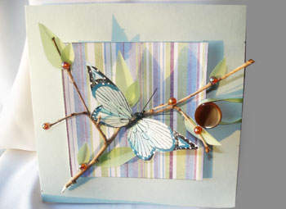
Over the next two weeks, choose the activities that best suit your girls. You may choose from the following suggestions, or use some of your own.

Butterfly Mother’s Day Card:

Equipment needed:
- Cardstock paper (coloured)
- Transparent green paper
- 1/2 cm ribbon (coloured)
- 1 medium-size button
- Butterfly (artificial)
- Double-sided tape (padded)
- Patterned design paper
- Small round beads (coloured)
- Glue or glue gun
- Scissors
- Tree branch (small)

How to make it:
Step 1:
- Cut out a 18cm x 36 cm square of coloured cardstock and fold in half.
- Cut out a 10cm x 10cm square of patterned design paper.
- Cut out a 10cm x 10cm square of coloured cardstock.
Step 2:
- Glue coloured cardstock and design paper together (10cm x 10cm square pieces).
- Place double-sided tape on back edges of coloured/design paper.
- Adhere the coloured/design square to front of card.
- Draw and cut leaves (small) out of transparent green paper and fold in middle.
- Glue leaves onto tree branch and round beads at base of leaves and on branches.
- Glue the butterfly onto tree branch and onto design paper.
Step 3:
- Glue a button (medium-sized) onto front of card at centre edge.
- Cut a 14cm piece of coloured ribbon, make a loop and knot the ends (cut off excess).
- Wrap loop over button and glue knotted end onto back of card.
- Glue (2) small leaves on top of knotted end and a round bead at base of leaf.

Tips:
- You could substitute the butterfly for other insects, animals or small birds.
- You can use various patterns of design paper and coloured cardstock.

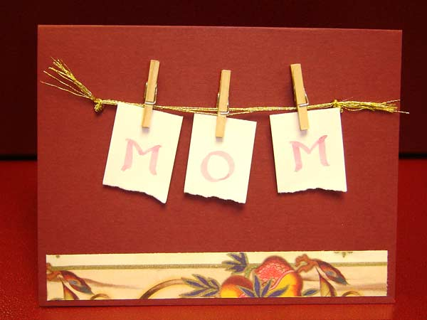
Card for MUM:

The girls will have lots of ideas for cards that they can make for their mums. Provide a variety of embellishments, stickers, ribbon, fancy paper, decals, fancy edged scissors –anything you can think of and let them go for it.

Photo frames with special verses for Mum and Grandma:
Print these verses out and the girls can mount them on to fancy paper and put them into a photo frame which they can then decorate with embellishments etc
I Love You Mum!
Mum's smiles can brighten any moment,
Mum's hugs put joy in all our days,
Mum's love will stay with us forever
and touch our lives in precious ways...
The values you've taught,
the care you've given,
and the wonderful love you've shown,
have enriched my life
in more ways than I can count.
I Love you Mum!

And Grandma's Too
"While we honour all our mothers
with words of love and praise.
While we tell about their goodness
and their kind and loving ways.
We should also think of Grandma,
she's a mother too, you see....
For she mothered my dear mother
as my mother mothers me."
Bath Ice-cream Bomb
Great for mum to use for a nice leisurely soak in the bath.
Equipment required:
- ½ cup Citric Acid
- ½ tbsp Water
- 1 ½ cup Baking Soda or Soda Bicarbonate
- 10-15 drops Fragrance Oil or Essential Oil
- 2 tsp Almond Oil or Apricot Kernel Oil
- 5 drops Food Colouring
Method
- Stir the dry ingredients well in a bowl.
- Drizzle in almond or apricot kernel oil, while stirring until the mixture is moistened.
- Add more fragrance or essential oil and base oil as needed and keep stirring until it mixes well.
- Add water so that the mixture is not crumbly.
- Roll the mixture in shape of a ball using your hands
- Put the ball in a lightly oiled round mould or ice-cream scoop to give it a better shape.
- Let it slip gently on a sheet of wax paper, where you have to leave it until it dries and gets set which may take a few days.
To finish:
- Wrap in cellophane and tie with curling ribbon and add a gift tag which the girls can make.
On the reverse of the gift tag print – “Add 1 bath bomb to the bath under running water to get that special fizzing spa-like bath that will help you relax.”
Chocolate drink
Put together all the ingredients for a yummy chocolate drink for mum, nicely presented in a jar, with instructions.
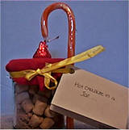
Materials Needed:
- Baby Food Jar
- Hot Cocoa Mix
- Miniature marshmallows
- Hershey Kiss Candy
- Small Candy Cane
- Fabric Scrap large enough to cover top of jar
- Ribbon
- Craft Glue
- Scissors
Instructions:
- Clean the baby food jar and make sure it is completely dry.
- Put a one cup serving of the hot cocoa mix into the jar.
- to the top with the miniature marshmallows. Put the cover on the jar tightly.
- Cut the fabric into a circle. Cut a piece of ribbon long enough to go round the top of the jar. Set the fabric circle centred on top of the jar lid. Tie the ribbon around the fabric along the edge of the lid. Tie a bow in the ribbon.
- Glue the Hershey Kiss candy to the top, centre of the lid.
- Glue the small candy cane onto the side of the jar. You can also tie the candy cane on with the ribbon.
- Print out these instructions and include them with your gift:
Hot Chocolate in a Jar
To warm yourself on a cold afternoon
pour this jar of chocolate and marshmallows
into a cup of hot water. Unwrap the Kiss
and drop it into your cup. Stir it all
together using the candy cane and enjoy!
Love your daughter.

Decorative Teacup:
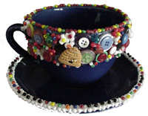
For the girls who are very creative and want to give their Mum something different, here is an unusual gift with this bead and button teacup.

Materials required:
- Solid coloured teacup with saucer
- Assorted decorative buttons and beads of different shapes, sizes, and colours.
- Hot glue gun and glue sticks.
- Tweezers

How to make it:
- Make sure the teacup is clean before beginning.
- Use the hot glue and glue all of the buttons and beads onto the surface of the teacup. The girls can just do the top half or the whole cup if desired.
- Continue to glue buttons and beads to the saucer as well.
- Use the tweezers to help place the beads and buttons on the cup. This will prevent the girls from getting burned, and will make it much easier.

